K6收流：

板子端

./iperf_i2_2.9 -s -i 1 -p 8888

电脑端

iperf.exe -c 172.19.24.202 -t 60 -i 1 -b 80M -p 8888

/mnt # ./iperf_i2_2.9 -s -i 1 -p 8888

------------------------------------------------------------

Server listening on TCP port 8888

TCP window size: 85.3 KByte (default)

------------------------------------------------------------

[ 4] local 172.19.24.202 port 8888 connected with 172.19.24.75 port 61982

[ ID] Interval Transfer Bandwidth

[ 4] 0.0- 1.0 sec 11.3 MBytes 95.1 Mbits/sec

[ 4] 1.0- 2.0 sec 11.3 MBytes 94.9 Mbits/sec

[ 4] 2.0- 3.0 sec 11.3 MBytes 94.7 Mbits/sec

[ 4] 3.0- 4.0 sec 11.3 MBytes 94.9 Mbits/sec

[ 4] 4.0- 5.0 sec 11.3 MBytes 94.9 Mbits/sec

[ 4] 5.0- 6.0 sec 11.3 MBytes 94.9 Mbits/sec

[ 4] 6.0- 7.0 sec 11.3 MBytes 94.9 Mbits/sec

[ 4] 7.0- 8.0 sec 11.3 MBytes 94.9 Mbits/sec

[ 4] 8.0- 9.0 sec 11.3 MBytes 94.9 Mbits/sec

[ 4] 9.0-10.0 sec 11.3 MBytes 94.9 Mbits/sec

[ 4] 10.0-11.0 sec 11.3 MBytes 94.9 Mbits/sec

[ 4] 11.0-12.0 sec 11.3 MBytes 94.9 Mbits/sec

[ 4] 12.0-13.0 sec 11.3 MBytes 94.9 Mbits/sec

[ 4] 13.0-14.0 sec 11.3 MBytes 94.9 Mbits/sec

[ 4] 14.0-15.0 sec 11.3 MBytes 94.9 Mbits/sec

[ 4] 15.0-16.0 sec 11.3 MBytes 94.9 Mbits/sec

[ 4] 16.0-17.0 sec 11.3 MBytes 94.9 Mbits/sec

[ 4] 17.0-18.0 sec 11.3 MBytes 94.7 Mbits/sec

[ 4] 18.0-19.0 sec 11.3 MBytes 94.9 Mbits/sec

[ 4] 19.0-20.0 sec 11.3 MBytes 94.9 Mbits/sec

[ 4] 20.0-21.0 sec 11.3 MBytes 94.9 Mbits/sec

[ 4] 21.0-22.0 sec 11.3 MBytes 94.9 Mbits/sec

[ 4] 22.0-23.0 sec 11.3 MBytes 94.9 Mbits/sec

[ 4] 23.0-24.0 sec 11.3 MBytes 94.9 Mbits/sec

[ 4] 24.0-25.0 sec 11.3 MBytes 94.9 Mbits/sec

[ 4] 25.0-26.0 sec 11.3 MBytes 94.9 Mbits/sec

[ 4] 26.0-27.0 sec 11.3 MBytes 94.9 Mbits/sec

[ 4] 27.0-28.0 sec 11.3 MBytes 94.9 Mbits/sec

[ 4] 28.0-29.0 sec 11.3 MBytes 94.9 Mbits/sec

[ 4] 29.0-30.0 sec 11.3 MBytes 94.9 Mbits/sec

[ 4] 30.0-31.0 sec 11.3 MBytes 94.9 Mbits/sec

[ 4] 31.0-32.0 sec 11.3 MBytes 94.7 Mbits/sec

[ 4] 32.0-33.0 sec 11.3 MBytes 94.9 Mbits/sec

[ 4] 33.0-34.0 sec 11.3 MBytes 94.9 Mbits/sec

[ 4] 34.0-35.0 sec 11.3 MBytes 94.9 Mbits/sec

[ 4] 35.0-36.0 sec 11.3 MBytes 94.9 Mbits/sec

[ 4] 36.0-37.0 sec 11.3 MBytes 94.9 Mbits/sec

[ 4] 37.0-38.0 sec 11.3 MBytes 94.9 Mbits/sec

[ 4] 38.0-39.0 sec 11.3 MBytes 94.9 Mbits/sec

[ 4] 39.0-40.0 sec 11.3 MBytes 94.9 Mbits/sec

[ 4] 40.0-41.0 sec 11.3 MBytes 94.9 Mbits/sec

[ 4] 41.0-42.0 sec 11.3 MBytes 94.9 Mbits/sec

[ 4] 42.0-43.0 sec 11.3 MBytes 94.9 Mbits/sec

[ 4] 43.0-44.0 sec 11.3 MBytes 94.7 Mbits/sec

[ 4] 44.0-45.0 sec 11.3 MBytes 94.9 Mbits/sec

[ 4] 45.0-46.0 sec 11.3 MBytes 94.9 Mbits/sec

[ 4] 46.0-47.0 sec 11.3 MBytes 94.9 Mbits/sec

[ 4] 47.0-48.0 sec 11.3 MBytes 94.9 Mbits/sec

[ 4] 48.0-49.0 sec 11.3 MBytes 94.9 Mbits/sec

[ 4] 49.0-50.0 sec 11.3 MBytes 94.9 Mbits/sec

[ 4] 50.0-51.0 sec 11.3 MBytes 94.9 Mbits/sec

[ 4] 51.0-52.0 sec 11.3 MBytes 94.9 Mbits/sec

[ 4] 52.0-53.0 sec 11.3 MBytes 94.9 Mbits/sec

[ 4] 53.0-54.0 sec 11.3 MBytes 94.9 Mbits/sec

[ 4] 54.0-55.0 sec 11.3 MBytes 94.9 Mbits/sec

[ 4] 55.0-56.0 sec 11.3 MBytes 94.9 Mbits/sec

[ 4] 56.0-57.0 sec 11.3 MBytes 94.9 Mbits/sec

[ 4] 57.0-58.0 sec 11.3 MBytes 94.9 Mbits/sec

[ 4] 58.0-59.0 sec 11.3 MBytes 94.7 Mbits/sec

[ 4] 59.0-60.0 sec 11.3 MBytes 94.9 Mbits/sec

[ 4] 0.0-60.1 sec 681 MBytes 94.9 Mbits/sec

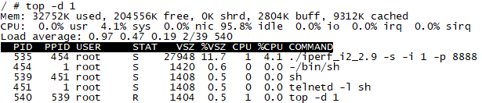

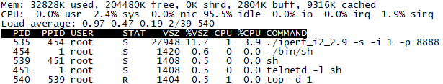

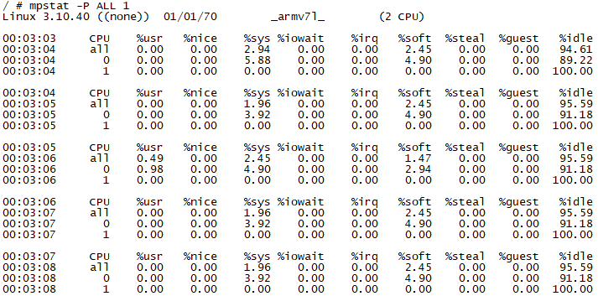

板子端：

./iperf_i2_2.9 –s –p 8888

电脑端：

iperf.exe -c 172.19.24.202 -t 60 –p 8888

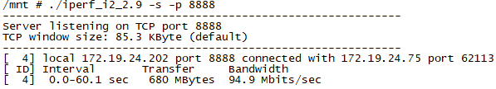

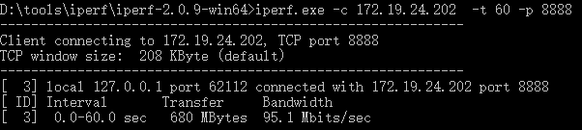

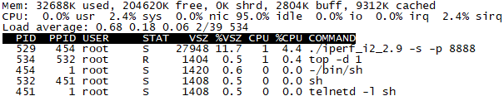

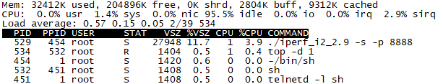

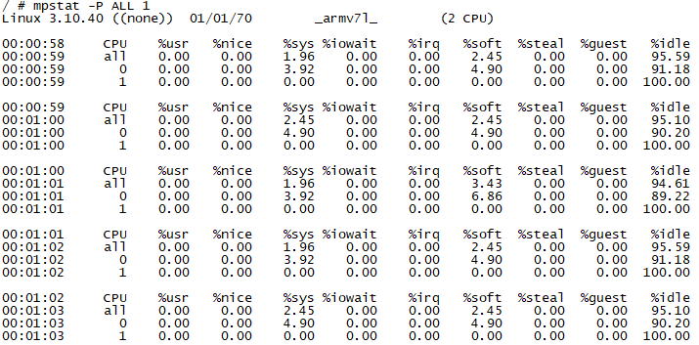

K6lite收流：

板子端

./iperf_i2_2.9 -s -i 1 -p 8888

电脑端

iperf.exe -c 172.19.24.202 -t 60 -i 1 -b 80M -p 8888

/mnt # ./iperf_i2_2.9 -s -i 1 -p 8888

------------------------------------------------------------

Server listening on TCP port 8888

TCP window size: 85.3 KByte (default)

------------------------------------------------------------

[ 4] local 172.19.24.202 port 8888 connected with 172.19.24.75 port 62031

[ ID] Interval Transfer Bandwidth

[ 4] 0.0- 1.0 sec 11.2 MBytes 94.2 Mbits/sec

[ 4] 1.0- 2.0 sec 11.3 MBytes 94.9 Mbits/sec

[ 4] 2.0- 3.0 sec 11.3 MBytes 94.9 Mbits/sec

[ 4] 3.0- 4.0 sec 11.3 MBytes 94.9 Mbits/sec

[ 4] 4.0- 5.0 sec 11.3 MBytes 94.9 Mbits/sec

[ 4] 5.0- 6.0 sec 11.3 MBytes 94.9 Mbits/sec

[ 4] 6.0- 7.0 sec 11.3 MBytes 94.9 Mbits/sec

[ 4] 7.0- 8.0 sec 11.3 MBytes 94.9 Mbits/sec

[ 4] 8.0- 9.0 sec 11.3 MBytes 94.9 Mbits/sec

[ 4] 9.0-10.0 sec 11.3 MBytes 94.9 Mbits/sec

[ 4] 10.0-11.0 sec 11.3 MBytes 94.9 Mbits/sec

[ 4] 11.0-12.0 sec 11.3 MBytes 94.9 Mbits/sec

[ 4] 12.0-13.0 sec 11.3 MBytes 94.9 Mbits/sec

[ 4] 13.0-14.0 sec 11.3 MBytes 94.9 Mbits/sec

[ 4] 14.0-15.0 sec 11.3 MBytes 94.9 Mbits/sec

[ 4] 15.0-16.0 sec 11.3 MBytes 94.9 Mbits/sec

[ 4] 16.0-17.0 sec 11.3 MBytes 94.9 Mbits/sec

[ 4] 17.0-18.0 sec 11.3 MBytes 94.9 Mbits/sec

[ 4] 18.0-19.0 sec 11.3 MBytes 94.9 Mbits/sec

[ 4] 19.0-20.0 sec 11.3 MBytes 94.9 Mbits/sec

[ 4] 20.0-21.0 sec 11.3 MBytes 94.9 Mbits/sec

[ 4] 21.0-22.0 sec 11.3 MBytes 94.9 Mbits/sec

[ 4] 22.0-23.0 sec 11.3 MBytes 94.9 Mbits/sec

[ 4] 23.0-24.0 sec 11.3 MBytes 94.9 Mbits/sec

[ 4] 24.0-25.0 sec 11.3 MBytes 94.9 Mbits/sec

[ 4] 25.0-26.0 sec 11.3 MBytes 94.9 Mbits/sec

[ 4] 26.0-27.0 sec 11.3 MBytes 94.9 Mbits/sec

[ 4] 27.0-28.0 sec 11.3 MBytes 94.9 Mbits/sec

[ 4] 28.0-29.0 sec 11.3 MBytes 94.9 Mbits/sec

[ 4] 29.0-30.0 sec 11.3 MBytes 94.9 Mbits/sec

[ 4] 30.0-31.0 sec 11.3 MBytes 94.9 Mbits/sec

[ 4] 31.0-32.0 sec 11.3 MBytes 94.9 Mbits/sec

[ 4] 32.0-33.0 sec 11.3 MBytes 94.9 Mbits/sec

[ 4] 33.0-34.0 sec 11.3 MBytes 94.9 Mbits/sec

[ 4] 34.0-35.0 sec 11.3 MBytes 94.9 Mbits/sec

[ 4] 35.0-36.0 sec 11.3 MBytes 94.9 Mbits/sec

[ 4] 36.0-37.0 sec 11.3 MBytes 94.9 Mbits/sec

[ 4] 37.0-38.0 sec 11.3 MBytes 94.9 Mbits/sec

[ 4] 38.0-39.0 sec 11.3 MBytes 94.9 Mbits/sec

[ 4] 39.0-40.0 sec 11.3 MBytes 94.9 Mbits/sec

[ 4] 40.0-41.0 sec 11.3 MBytes 94.9 Mbits/sec

[ 4] 41.0-42.0 sec 11.3 MBytes 94.9 Mbits/sec

[ 4] 42.0-43.0 sec 11.3 MBytes 94.9 Mbits/sec

[ 4] 43.0-44.0 sec 11.3 MBytes 94.9 Mbits/sec

[ 4] 44.0-45.0 sec 11.3 MBytes 94.9 Mbits/sec

[ 4] 45.0-46.0 sec 11.3 MBytes 94.9 Mbits/sec

[ 4] 46.0-47.0 sec 11.3 MBytes 94.9 Mbits/sec

[ 4] 47.0-48.0 sec 11.3 MBytes 94.9 Mbits/sec

[ 4] 48.0-49.0 sec 11.3 MBytes 94.9 Mbits/sec

[ 4] 49.0-50.0 sec 11.3 MBytes 94.9 Mbits/sec

[ 4] 50.0-51.0 sec 11.3 MBytes 94.9 Mbits/sec

[ 4] 51.0-52.0 sec 11.3 MBytes 94.9 Mbits/sec

[ 4] 52.0-53.0 sec 11.3 MBytes 94.9 Mbits/sec

[ 4] 53.0-54.0 sec 11.3 MBytes 94.9 Mbits/sec

[ 4] 54.0-55.0 sec 11.3 MBytes 94.9 Mbits/sec

[ 4] 55.0-56.0 sec 11.3 MBytes 94.9 Mbits/sec

[ 4] 56.0-57.0 sec 11.3 MBytes 94.9 Mbits/sec

[ 4] 57.0-58.0 sec 11.3 MBytes 94.9 Mbits/sec

[ 4] 58.0-59.0 sec 11.3 MBytes 94.9 Mbits/sec

[ 4] 59.0-60.0 sec 11.3 MBytes 94.9 Mbits/sec

[ 4] 0.0-60.1 sec 680 MBytes 94.9 Mbits/sec

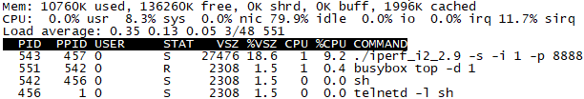

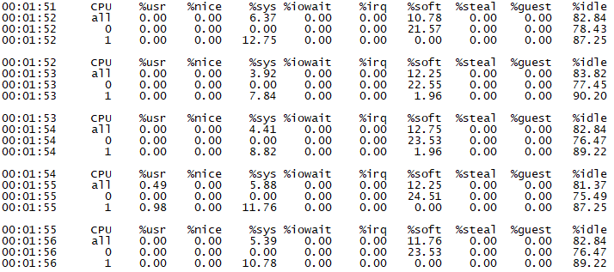

板子端：

./iperf_i2_2.9 –s –p 8888

电脑端：

iperf.exe -c 172.19.24.202 -t 60 –p 8888

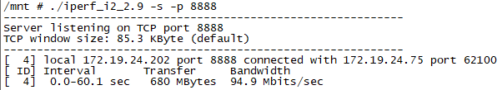

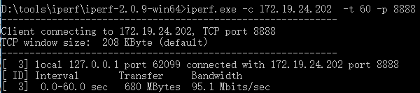

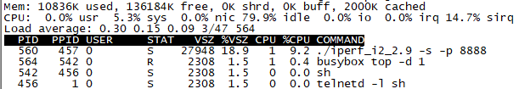

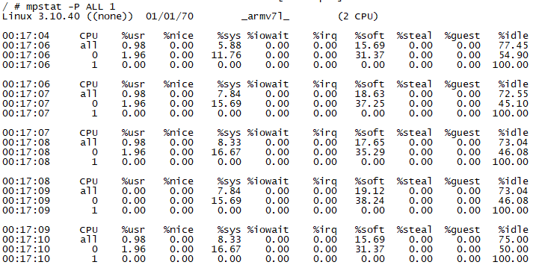

I2 收流：

板子端：

./iperf_i2_2.9 –s –p 8888

电脑端：

iperf.exe -c 172.19.24.202 -t 60 –p 8888

